Siglent SSG3032X (signal generator)
This produces an RF signal we want to modulate. The modulation should be synced with the other components
There are 3 ways to externally control the modulation

External amplitude modulation input
Needs a signal from -1V to 1V (2Vpp) for modulation, in which 1V is max amplitude (on), and -1V is zero amplitude (off).
Downside : The imperfections of the modulation signal (things like overshoot) get copied to the RF signal

Pulse in
Triggers around 1.6V (CMOS 3.3 V).
Expects the full pulse train, with low being off, and high being on (The Siglent can also be configured to inverse this). 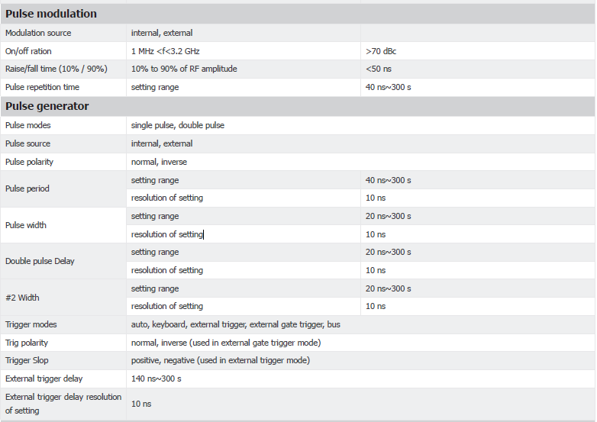

Trigger in
Triggers around 1.6V (5 V TTL)
Expects a trigger pulse (can be configured to trigger on rising or falling edge) when the pulse train needs to start. A delay can be configured.
Downside: The pulse train would need to be programmed into the Siglent.
Our preference is option 2, where the pulse train is programmed into the Red Pitaya and then delivered to the Siglent as on/off commands.

Timeharp 260 P (photon counter)
This detects/counts the pulses made by the photon detectors. This needs to get a sync pulse so it knows when the measurement starts.
The sync pulse is currently controlled by the pulse out of the Siglent (CMOS 3.3 V), but this needs to now be done by the Red Pitaya.
The two (= signal and sync) inputs of the Timeharp both trigger on the edge of a signal between 0 and -1 V (at trigger levels that can be adjusted in the Timeharp program). Hence, we typically use an invertor and a set of attenuators (in total 10 dB or more) to covert the TTL (0 to +5 V) signals from Siglent and photon counter to the required input.

Acousto-optical modulator (AOM) (laser modulation)
Expects a TTL signal with high turning the deflection of the laser on, and low turning the deflected laser beam off. (Note: we don’t have the AOM in the lab yet and the on and off signals might be the other way around)
Alternatively, it can be provided with an analog signal between 0 and 5V to manually provide the modulation signal.

Signals to be generated

A sync pulse for the Timeharp, once per measurement.
Preferably timed simultaneously with the read-pulse for the AOM, but the most important part is that it is consistent.

A configurable pulse train for the Siglent
A pulse train of 1 or more pulses. The pulse widths will be either t_{π} or t_{π} /2, with t_{π} being order 0.1 -1 µs long.
The distance between pulses will be τ, order 1 - 30 µs long.
A typical pulse sequence will look like this: (i) t_{π}/2 pulse, (ii) wait time τ, (iii) t_{π} pulse, (iv) wait time τ, (v) t_{π}/2 pulse (see figure below). Alternative pulse sequence start from this sequence but contain (N-1) additional copies of the block (ii)+(iii)+(iv), such that the N intermediate t_{π} pulses will be separated from each other by a time 2 τ.
It would be nice to also be able to do a simpler scheme with a t_{on} an t_{off} (basically one long pulse), both order 1-100 µs long.

A configurable pulse train for the AOM
The AOM needs 1 or 2 pulses per measurement: a prepare and read pulse, or a combined read-prepare pulse. These need to be order microseconds long. It would be nice to be able to put the read pulse as close as possible after the last pulse send to the Siglent.
It would be nice to also be able to forgo the modulation entirely.

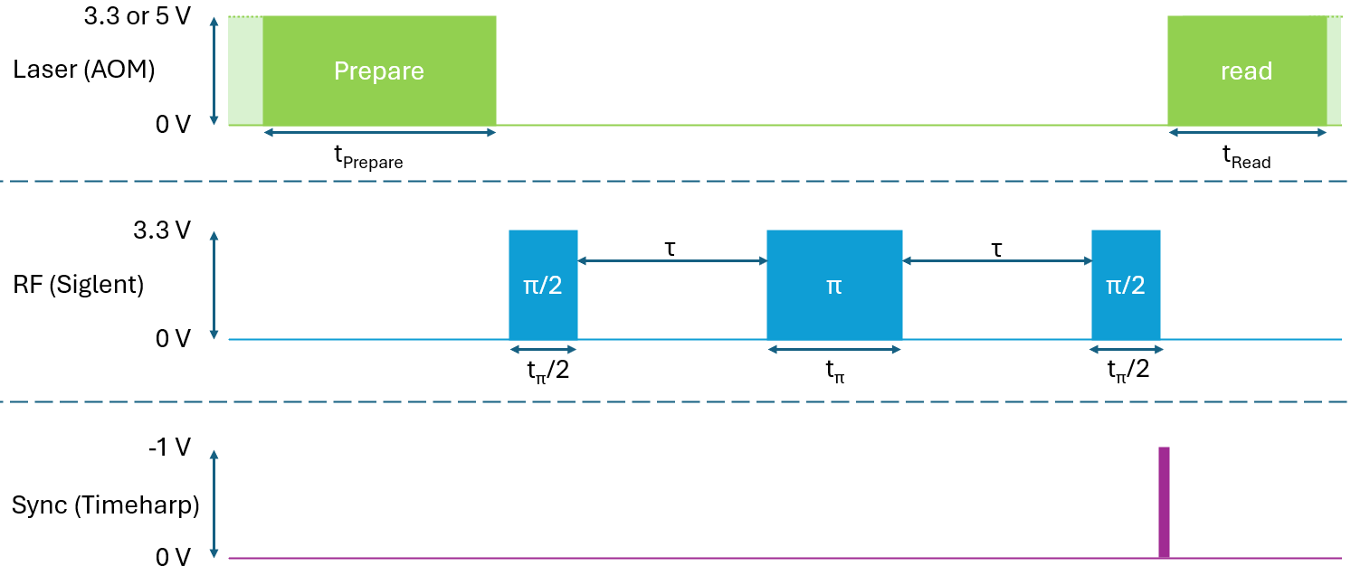
Example of an experiment (Hahn echo) we want to do with this setup.
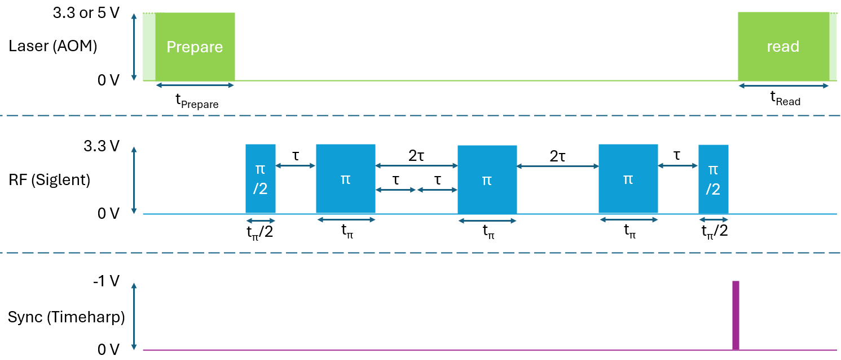
Example of an experiment (N=3 Repeated pulses) we want to do with this setup.
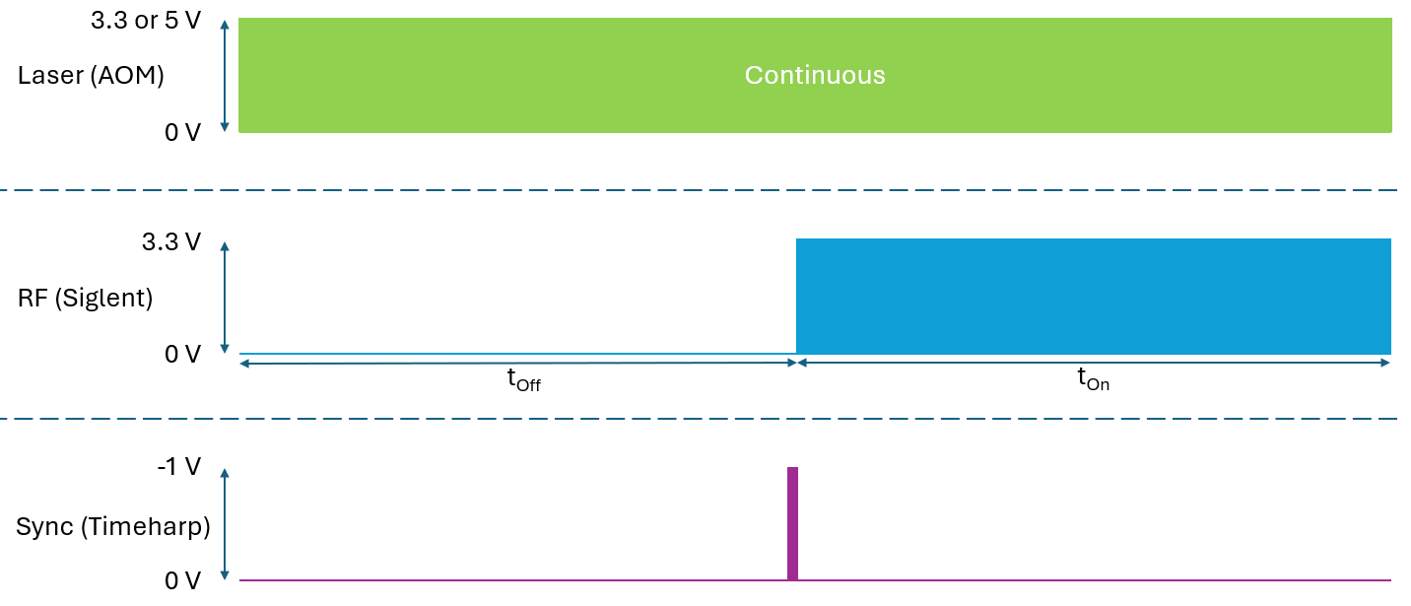
Example of an experiment (Rabi Oscillation) we want to do with this setup.
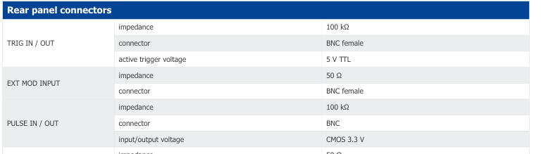
Taken from the Siglent datasheet

